Chapter 7, Solution 80.

In the circuit of Fig. 7.144, assume that the switch has been in position A for a long time, find:
- i₁(0), i₂(0), and v₀(0)
- i_{L}(t)
- i₁(∞), i₂(∞), and v₀(∞)

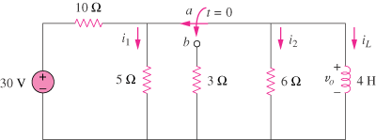

Figure 7.144
For Prob. 7.80.

Solution

- When the switch is in position A, the 5-ohm and 6-ohm resistors are short-circuited so that

but the current through the 4-H inductor is i_{L}(0) =30/10 = 3A.

- When the switch is in position B,

(c)

